**SAMSUNG MOBILE PHONE**

**(Research)**

**by**

**Waqar Ali Khan**

**1. Introduction:**

Samsung Mobile Division is one of five divisions within Samsung Electronics, belonging to the Samsung Group, and consists of:

* Mobile Communications Division
* Telecommunication Systems Division
* Computer Division
* MP3 Business Team
* Mobile Solution Centre and Telecommunication R&D Centre

Telecommunication Business produces a full spectrum of products from mobiles and other mobile devices such as MP3 players and laptop computers to telecommunication network infrastructure. Headquarters is located in Suwon, South Korea.

Samsung launched [Galaxy Tab](https://propakistani.pk/2010/12/21/mobilink-and-samsung-jointly-launch-galaxy-tablet/) and other Touch Screen handsets in Pakistan exactly the same time when they were introduced in other parts of the world.

These Samsung powered smartphones received amazing and overwhelming response locally, which depicts the solid market potential in Pakistan for high-end and expensive brands of Smartphones”, said Mr. Qureshi.

Samsung introduced its different Smartphones, one after another, and obtained a better-than-expected result in terms of popularity, demand and sales hence the number of buyers has been increasing significantly in the past year.

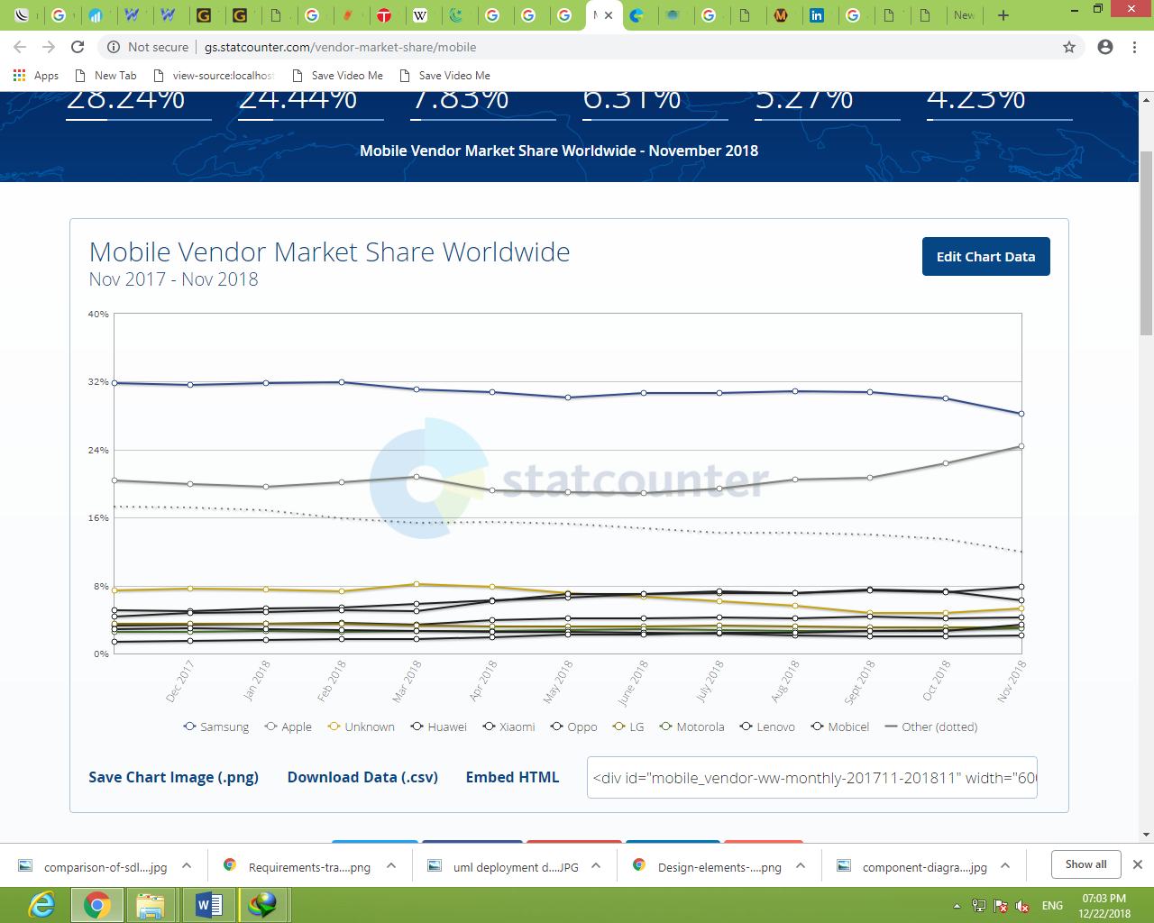

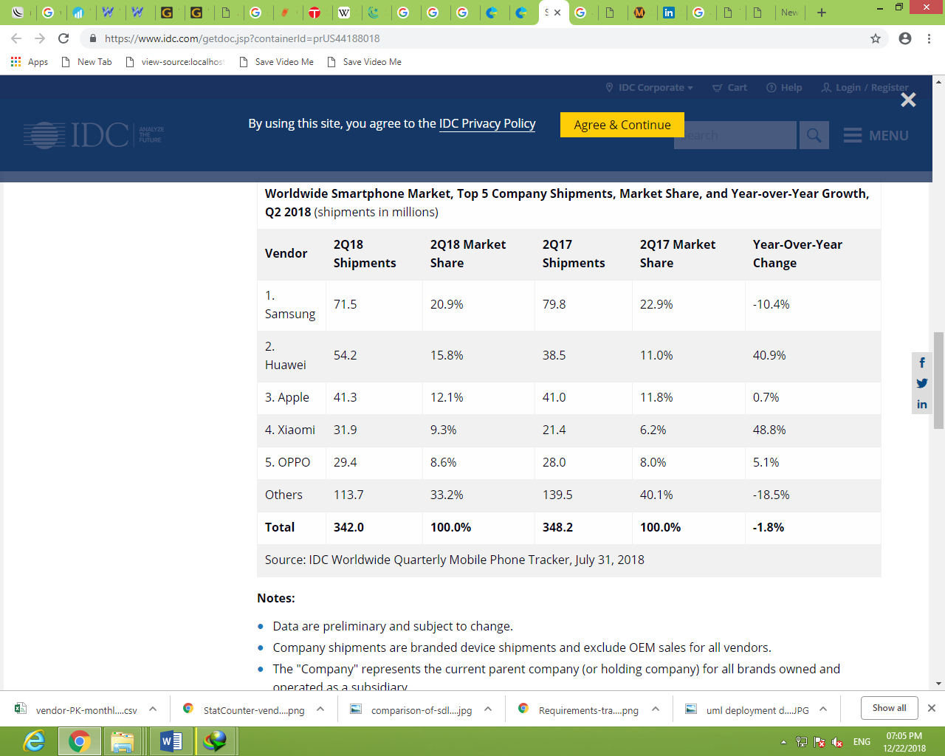

**2. Scope**

In this research, I chose to focus on the marketing strategy implemented by Samsung for its smartphone products, because the purpose of marketing is to act in a way that a company delivers products in the market that they correspond to demand. That it satisfies its customers’ needs and wants with significant and sustainable competitive advantage and profit as noted with Samsung.

Moreover, Samsung’s success may be affected by factors outside the scope of marketing strategy; these will be discussed briefly but are not included in the analysis of this thesis. This research will consider only the marketing strategy factors, affecting Samsung’s performance in the European market and global market at large. This research will discuss mainly the marketing decisions of the company in the smartphone market not considering much the mobile market, as the mobile products is sidelined due to changing customers’ needs. The study will concentrate on the consumer perception regarding Samsung marketing strategy to structure the conclusion of the studies.

**3. Research Questions**

The purpose for this research is to explore the marketing scope of Samsung mobile phones, and the particular introduction decisions of the company when marketing its smartphone products. The goal of this analysis is to understand whether there is evidence to conclude that Samsung’s performance in the smartphone market has been positively affected by the marketing strategy decisions and implementation.

**4. Strategy Analysis for Smartphones**

After understanding the marketing mix of products, I can continue fitting it into marketing strategy. This study will assist me in determining whether the choice of strategy used is correct and whether it’s implemented in the right way. The product’s introduction stage, a business, can choose between niche strategy and penetration strategy (Shaw, 2012).

The penetration strategy should use aggressive marketing mix such a low price, low service and high promotional expenditure (Shaw, 2012). He further noted that the other option, which is the niche strategy, is good for small companies that use high price and a product for a niche market. A view in the smartphone industry at large, and putting into consideration that the price as a factor that most consumers consider in the business, I will choose two different approaches. I recommend that, in the introduction stage of a smartphone, a company can choose between niche strategies, with the marketing mix suited for particular market segment. This may include, low or high price, and can be used by big or small business. I also find it appropriate to use the differentiation strategy instead of penetration strategy, which is good for different business sizes and price levels. However, I recognized the need in the smartphone market; a company needs to use the differentiation strategy with aggressive marketing mix. This is because of the competition in the smartphone market and strong trend of coping within the smartphone industry.

As the strategy models available have been analyzed for the research, two models are noted that suits best with this analysis. I have selected Porters’ Generic strategies and Smith’s differentiation and segmentation strategies. According to my research, and by examining the market situation, of the smartphone industry, these two strategies, fit well my knowledge in strategic options, in the introduction stage of a smartphone in the market. I settled with these two models since they are similar and will provide stronger evidence the findings.

**5. Findings and Discussions**

The quantity of students dominates the research with a total of 11 students out of the 20 respondents. High number of respondents lay between the age of 26years and 40 years.

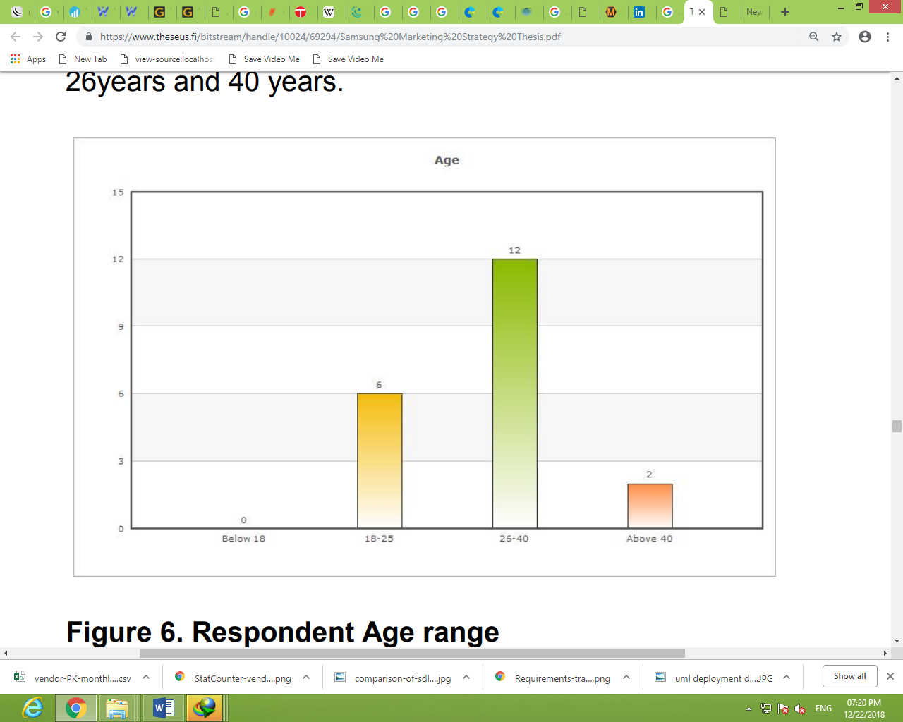

**5.1. Brand of Smartphones Owned By Respondents**

Mostly, they use Samsung smartphone with the percentage of 55%. Nokia comes second with 30% and then iPhone with 15%.

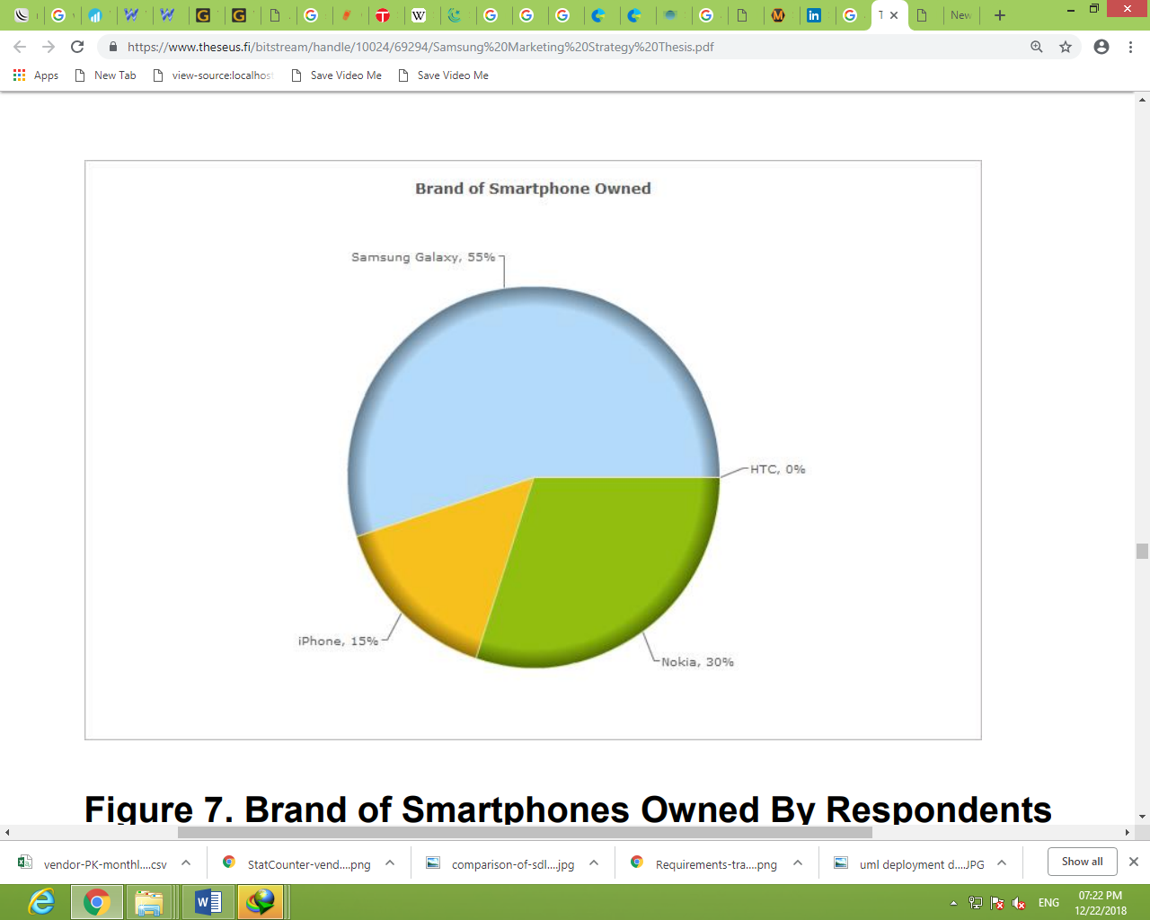

**5.2. Reasons for purchasing Smartphones**

Their reasons for buying a smartphone resulted with applications being highest with 68%, then price followed with 26%, and advertisement came last with 5%. Even though the applications are the main reason for the respondents to buy a smartphone, according to this analysis it seems that most of them don’t usually use all the applications offered. The result of the data collected showed 26% of the respondents use all the applications while 74% do not use the applications

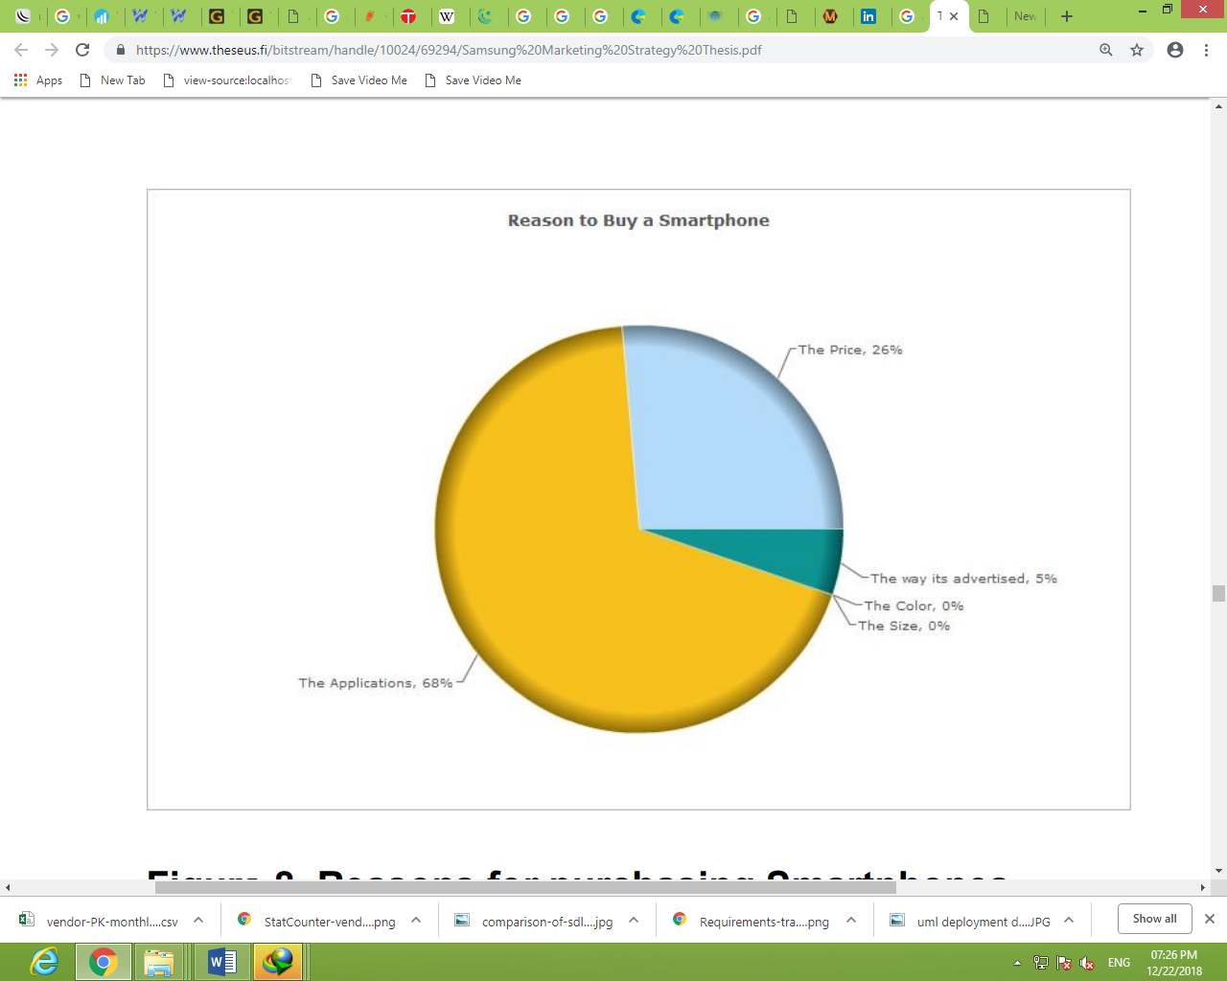

Consumer perception to the product Overall, the perception of the twenty respondents towards Samsung smartphone is good. Fifteen of the twenty respondents said they would buy Samsung smartphone over iPhone in the question on which smartphone, one prefers to buy between iPhone and Samsung.

Below are some of the reasons the respondents gave.

“I would go for the Samsung smartphones because they are more attractive, for example, the galaxy. In addition, most of the applications on Samsung smartphones are free, and I don't need to register my card to download them, compared to apple whose applications are hard to access.”

“Samsung smartphones. They are easy to use, durable and uncomplicated”.

“I prefer Samsung since I’m used to them”

“I would still buy Samsung Smartphone because of its quality and the fact that the size is big enough especially when I am checking emails and writing them”

“Samsung, availability of applications”

“Samsung Smartphone because it has good applications, takes good pictures and quick”

“They are durable and innovative. The user interface is not my cup of tea though”.

“I believe Samsung has the best quality, and I would buy a Samsung Smartphone again and again. I trust the brand; it’s strong and very durable”. “Easy to use, android operating system gives free applications”.

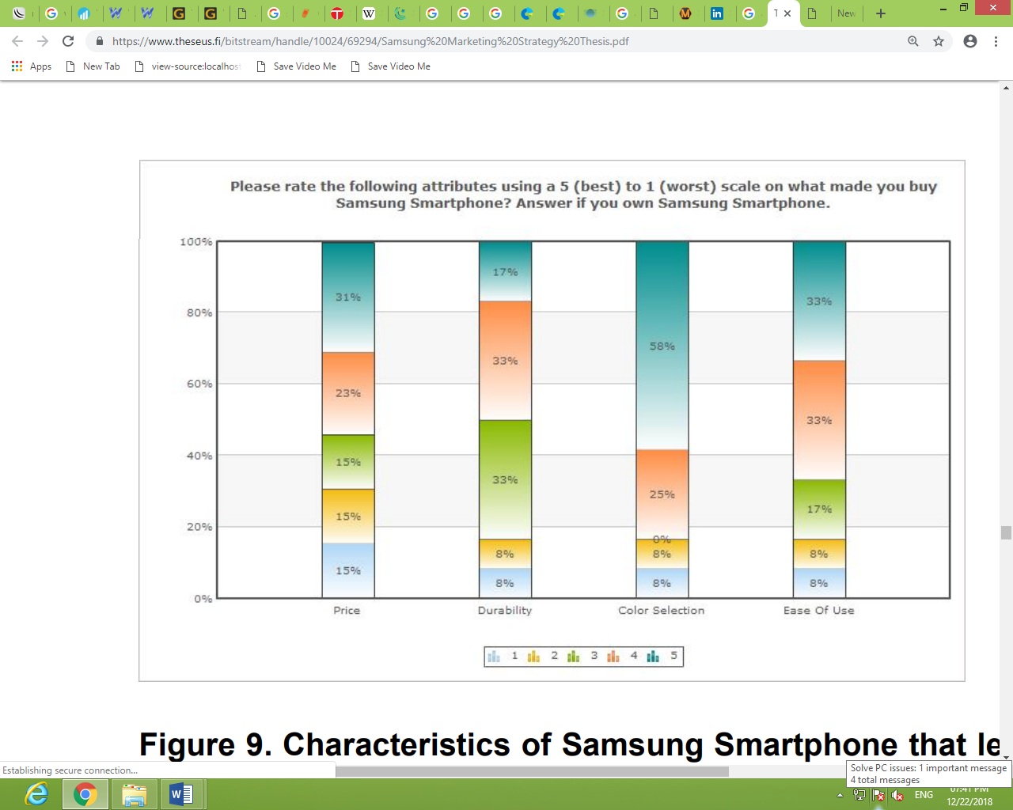

**6. CONSUMER BEHAVIOUR**

Consumer behavior is the study of how individual customers, groups or organizations select, buy, use, and dispose ideas, goods, and services to satisfy their needs and wants. It refers to the actions of the consumers in the marketplace and the underlying motives for those actions.

CONSUMERS DECISION STYLE

* Brand conscious
* Recreation conscious
* Price conscious
* Fashion conscious
* Brand loyal
* Prior experience

**6.1 AGE OF THE RESPONDENTS**

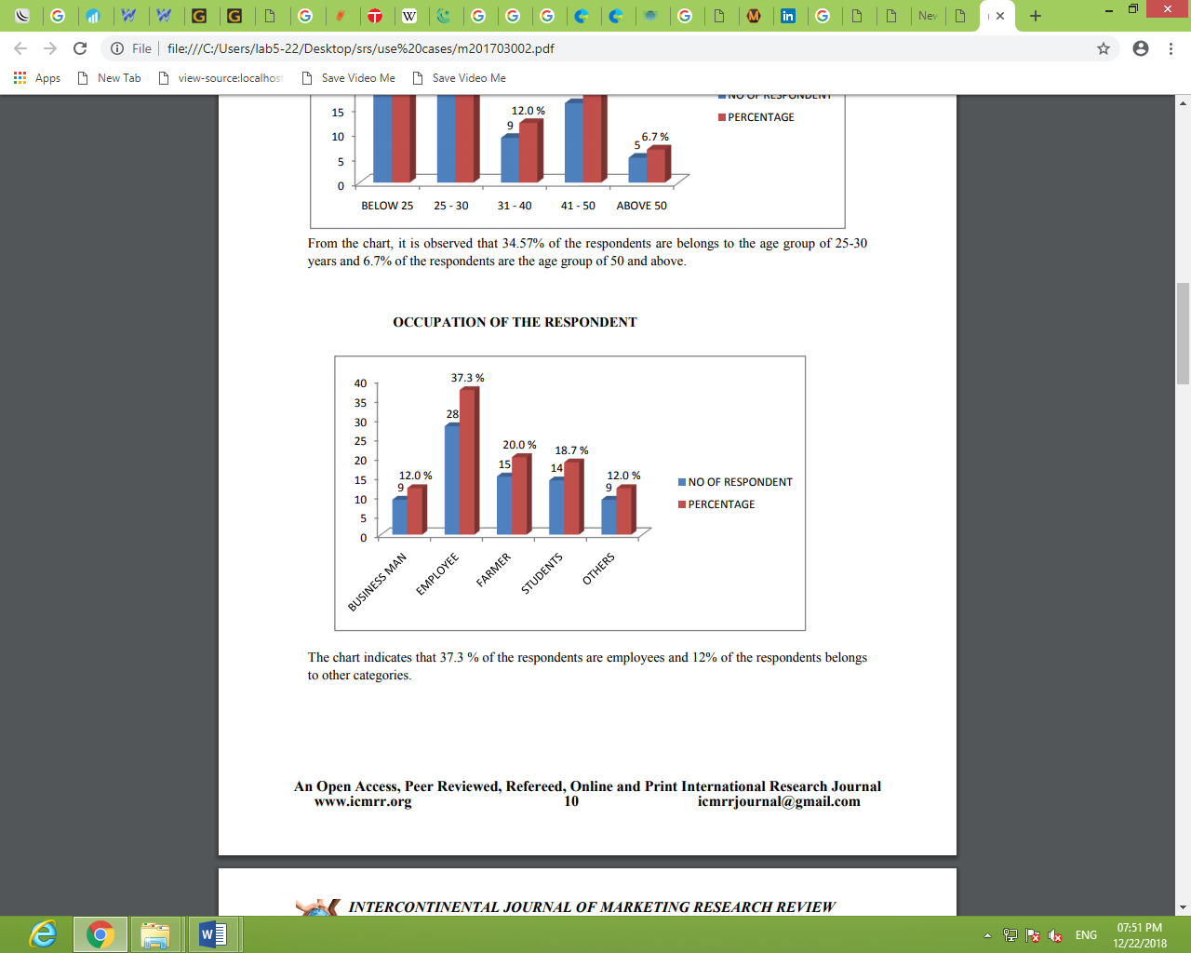

From the chart, it is observed that 34.57% of the respondents are belong to the age group of 25-30 years and 6.7% respondents are the age group of 50 and above.

**6.2 OCCUPATION OF THE RESPONDENT**

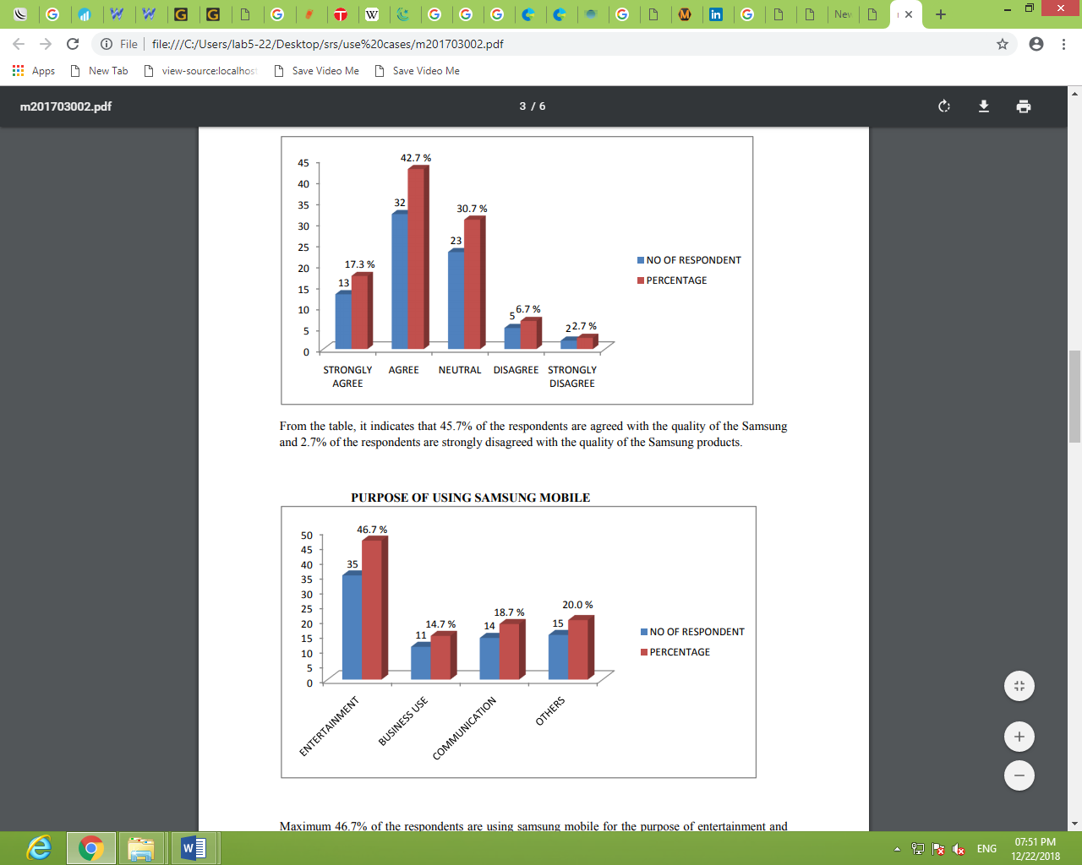

The char indicates that 37.3% of the respondents are employees and 12% of the respondents belongs to other categories.

**6.3 PURPOSE OF USING SAMSUNG MOBILE**

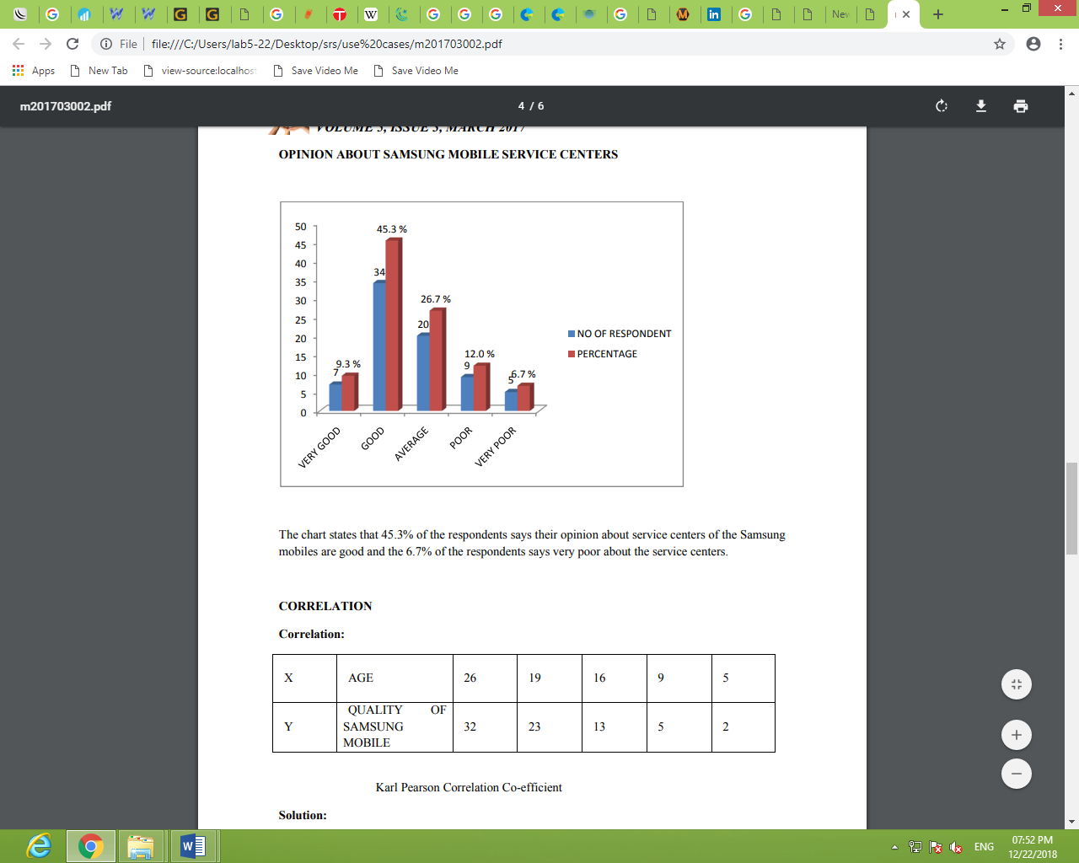

Maximum 46.7% of the respondents are using samsung mobile for the purpose of entertainment and 14.7% of the respondents are using for the purpose of the busniess.

**7. Samsung Galaxy Market Analysis:**

### **7.1 Introduction**

The market analysis is one of the fundamental aspects of the startup on any marketing strategy.  Appropriate execution of the market analysis gives the company a clear roadmap for the implementation of its strategy (Goi, 2009, p. 3). Additionally, an outstanding market analysis will enable the company to attract new investors, overcome the challenges in the environment of the business and as well attract a new pool of customers (English, 2001, p. 22). This paper aims to carry out the market analysis of Samsung Galaxy Company. To address this aspect, the paper focuses on the company’s marketing scope and objectives.

**7.2 Industry Market Overview**

The smartphone industry is dominated by the variety of the industry players. This is because Android operating system is open to new entrants who may be willing and have the potential to enter the industry. This calls for the existing players in the industry to establish robust marketing strategies to compete successfully with new entrants as well as among themselves. The key leaders in this industry include Motorola Solutions Inc. LG Electronics, Apple Inc., and Samsung Electronics.

**7.3 Samsung Galaxy Market Analysis**

For many decades Samsung has been a global leader in mobile phone market. This success is attributable to the company cost saving mechanisms as well as provision of unique products to its customers (Bhasin, 2016). This has helped in placing the company in the leading position in the industry of smartphone. Additionally, the demand for the company products has increased with the majority of the consumers of the company products being the population group aged between fourteen and forty-nine years. The demand for the company products in the market is determined by the consumer spending, product price as well as success and timing of introducing the new product into the market. However, the customers have been arguing for the highly quality products at cheap cost. This becomes difficult because of the costly components used to manufacture the smartphones.

**7.4 Market Analysis Scope**

For an extensive and comprehensive exploration of the Samsung marketing analysis, this paper focuses on the principles of marketing applied by the company. This area of scope has enabled the company to attain effective and sustainable competitive advantage. Some of the aspects that have facilitated the continued prosperity of Samsung Galaxy are as discussed below:

**7.5 Market Segmentation**

Segmentation of the market for any organization is very vital as it helps the company to design the product as the preferences of the target market (Ali & Talwar, 2013, p. 24). Market segmentation is the process whereby the company thrives on having a clear knowledge of its target market (Tynan, et al., 2010, p. 1159). The segmentation process helps the company in meeting satisfactory the demands of the target customers. For Samsung, marketing segmentation has been faced on the various variables such as behavioral, psychographic, demographic and geographic segmentation.

**7.6 Geographic Segmentation**: Samsung targets the customers both in the domestic and in the foreign markets. To perfect its marketing strategies the company adopts different strategies for different regions. For example, to attract more customers in the target market of India, the company created a keyboard with nine Indian languages (Author, 2014).

**7.7 Demographic Segmentation**: demographic segmentation entails designing the products according to the tests and preferences of the various age brackets within the population (Vallaster, et al., 2012, p. 38). Samsung has effectively and successfully adopted this technique by coming up with the different brands of products for different members in the target market. For example, it was the first company to come up with “mini”, “mega” and “zoom” aspect in the marketing of mobile (Author, 2014).

**7.8 Psychographic segmentation**: This segmentation technique involves the use of common traits such as personality and lifestyle among the target market customers. Samsung Galaxy targets the customers of the high lifestyle and that it way it manufactures high quality as well as expensive smartphones.

**7.9 Behavioral Segmentation**: This aspect of marketing targets the customers who portray similar behavior.  For example, Samsung Galaxy targets the behavior of the customers during festive seasons when they are likely to spend on the purchase of the smartphones as the gifts to their loved ones.

**8. CONCLUSION**

The smart phone is no longer the exclusive property of early adopter. Streamlining mobile Internet and 3G mobile communications has opened up boundless possibility for the smart phone, and the innovative idea toward the mobile Internet world leads this generation to the genuine ubiquitous world by the innovativeness of the smartphone.

Users are now able to handle almost all of the activities in everyday life with small mobile Internet solutions in their hands. If the development of the Internet made the world into one large community, the popularization of the smartphone will return the world to a multipolar Internet world, which is much more diversified and personalized.

Therefore, I try to illustrate possible issues related to the popularization of the smart phone other than business issue. It seems that smartphone-related research can be largely divided into three areas: the technological requirements of smartphones, business viewpoints on the IT industry, and a socio-human approach in a sense of the beginning of mobile Internet society.

I am very interested to compare three important dimensions in modern society: technology, management, and humanity. Technology plants the seed for innovative change in life. Exceptional management skills realize technology throughout everyday life. Humanity warns of the negative possibilities resulting from the other two aspects. I think it is the smart phone that makes modern people think of these three perspectives. The smartphone has overcome the previous limitations on IT technology. While we are still deciding whether the smartphone is of benefit to us, we are living in the IT world and are given no choice but to receive IT benefits. Ultimately, we anticipate how the smartphone will transform our lives even more and predict what IT device awaits us next.